**General**

This Emergency Preparedness and Response Plan defines the framework for preparing, responding and mitigating potential emergency situations, including:

* Fire
* The provision of first aid [Injury or Accident].
* Environmental incidents and emergencies.

**Purpose**

The purpose of this Emergency Preparedness and Response Plan is to ensure that adequate arrangements are in place for the protection of all employees and other persons that may be present in the area or premises in the event of an emergency occurring.

In the event an emergency, the safety of human life shall override all other considerations, such as saving property or protecting the environment. Once human life is protected then other effects can be accounted for and action taken.

**Emergency Impact Assessment**

As part of the arrangements to an emergency, an impact assessment has been undertaken by INFRATEC and the arrangements for responding to the emergency are taken into account during the impact assessment process.

**Emergency Alarm Arrangements**

INFRATEC have ensured that an appropriate alarm system is in place in the event of an emergency occurring or being advised of an emergency situation.

**Information and Training**

INFRATEC have provide relevant information and training to all employees and relevant interested parties, including persons working under its control. related to emergency preparedness and planned response, as appropriate.

**Testing the Emergency Preparedness and Response Plan**

INFRATEC periodically test and exercise the planned response capability and actions, where practicable. evaluating performance and, as necessary, revising the planned response, including after testing and, in particular, after the occurrence of real emergency situations;

**Communicating the Emergency Preparedness and Response Plan**

INFRATEC communicate and providing relevant information to all workers on their duties and responsibilities. And communicate relevant information to contractors, visitors, emergency response services, government authorities and, as appropriate, the local community taking into account the needs and capabilities of all relevant interested parties and ensuring their involvement, as appropriate, in the development of the Emergency Preparedness and Response Plan.

**Vulnerable people**

INFRATEC plan to provide additional assistance to people with a disability, people with learning difficulties, those with limited mobility.

**First Aid Response**

INFRATEC have assess the first aid requirements of their work place and have ensured there are enough trained first aiders and facilities to help casualties of illness or injury immediately, identifying which items are need in the worksite first aid kit and that an ambulance or other professional help can be summoned without delay.

**Actions to be taken in event an emergency situation**

Regardless of the type of emergency, the response plan will be as follows:

* Raise the alarm.
* Inform employees, visitors and contractors of the emergency.
* Utilise on-site emergency response equipment [Only if trained to do so].
* Summon the emergency services [i.e., call 999] and continuing to liaise with them.
* Manage people, including evacuation [where necessary].
* Evacuate people with disabilities [where necessary].
* Manage traffic, including emergency vehicles.
* Incident control.
* Provide first aid and medical assistance.

**Fire**

For emergency situations involving fire, [IMD043 Fire and Emergency Evacuation Plan] will be followed.

**The provision of first aid [Injury or Accident].**

For emergency situations involving Injury or Accident, the response plan will be as follows:

* Assess the condition of the injured worker and determine if medical treatment is needed. If the injured employee needs immediate medical assistance, dial 999 Ask for the ambulance service. Be prepared to give details of: the nature of the accident/injury; the condition of the casualty; your exact location [name of building and building address].
* If the employee requires medical attention, an ambulance is not needed, a member of staff should take the injured employee to a medical facility.
* If an employee only requires first aid and doesn’t want to go to a medical facility, this can be provided on-site by first aiders. [Names and contact details for on-site first aiders are listed in all areas of the building].
* First Aiders must identify and mitigate potential dangers. [Make sure the area is safe before administering first aid].
* Administer the required first aid.
* The incident will need to be recorded and documented.

**Environmental incidents and emergencies.**

For emergency situations involving environmental incidents and emergencies, the response plan will be as follows:

* Potential environmental incidents and emergencies likely to occur at the facility are identified by the Compliance Manager.
* Methods to respond to, mitigate and prevent environmental emergencies are established and maintained at the facility by the Compliance Manager.
* Roles and responsibilities for communications within the facility and for obtaining outside support services shall be established and maintained.
* Environmental emergency methods and communications will be tested at least annually and records of these tests maintained.
* Following an environmental emergency, the cause of the emergency and corresponding emergency methods will be reviewed.
* Actions identified, and methods of response to, mitigate and prevent release will be amended as required.
* Where applicable, regulatory agencies will be notified of environmental incidents.
* All emergency response activities are to be conducted by trained responders as appropriate, and in compliance with regulations, permits or consents.
* Environmental incidents will need to be recorded and documented.

**Accident Emergency Hospital**

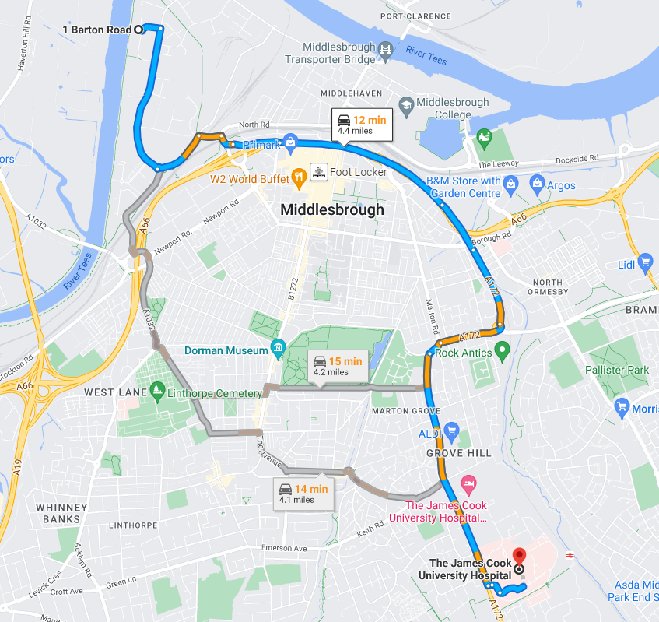

**The James Cook University Hospital**

**Marton Rd, Middlesbrough TS4 3BW**

**01642 850850**

**Key Contacts**

|  |  |  |
| --- | --- | --- |
| **Contact** | **Contact Number** | **Useful information** |
| **Managing Director** | 07798 704818 |  |
| **Operations Director** | 07970 813422 |  |
| **Financial Controller** | 07968 767250 |  |
| **Commercial / Compliance Manager** | 07494 749243 |  |
| **Transport Manger** | 07793 610920 |  |
|  |  |  |
| **Police** | Emergency 999  Non-emergency 101 |  |
| **Fire** | Emergency 999  01642 811640 |  |
| **Hospital** | Emergency 999  01642 850850 |  |
|  |  |  |
| **Gas (Gas Emergency Service)** | 0800 111999 |  |
| **Electricity (Northern Powergrid)** | 0800 668877 |  |
| **Northumbrian Water** | 0845 7171100 |  |
|  |  |  |
| **Health and Safety Executive. [HSE]** | 0300 003 1747 |  |
| **Environment Agency incident hotline** | 0800 80 70 60 |  |

**Event Log Sheet**

|  |  |  |  |
| --- | --- | --- | --- |
| **Date** | **Time** | **Information / Decisions / Actions** | **Initials** |
|  |  |  |  |
|  |  |  |  |
|  |  |  |  |
|  |  |  |  |
|  |  |  |  |
|  |  |  |  |
|  |  |  |  |
|  |  |  |  |
|  |  |  |  |
|  |  |  |  |
|  |  |  |  |
|  |  |  |  |
|  |  |  |  |
|  |  |  |  |
|  |  |  |  |
|  |  |  |  |
|  |  |  |  |
|  |  |  |  |
|  |  |  |  |
|  |  |  |  |
|  |  |  |  |
|  |  |  |  |